For Immediate Release:
Illegal wildlife trade (IWT) is a leading threat to biodiversity globally. Experts from across the globe will convene in London next week to explore strategies to tackle IWT.

Five of the UK’s most active research organisations are convening an event on the evidence that underlies conservation strategies to address IWT. Research plays a central—but often overlooked—role in finding real-world solutions to the complex and rapidly changing challenges of illegal trade.
In response, experts are gathering challenge myths about IWT, highlight the latest evidence, and articulate gaps in our current understanding of IWT—working to inform the upcoming UK Government’s London Conference on Illegal Wildlife Trade.*

Evidence to Action: Research to address illegal wildlife trade
Zoological Society of London, Outer Circle, London NW1 4SX
Tuesday 9 October
Evidence to Action will gather more than 270 researchers, community members, practitioners, journalists and decision-makers to explore the science of our responses to IWT, including their implications for wildlife, livelihoods and policy. It will cover topics such as:
- Innovative technologies, including forensic innovations, drones, AI, machine learning, online trade and social media
- “Forgotten” IWT, including forgotten species endangered by IWT (e.g., orchids, hornbills, fish), overlooked markets (e.g., UK, Europe and Latin America), and animal welfare
- The importance of gender to IWT interventions
- The role of media in reporting on complex and emotional IWT stories
- Park rangers and the controversial militarization of conservation
- Product substitution in IWT (e.g. lion bones used in place of tiger bones)
- The use of celebrities to tackle wildlife trade
Want to learn more?
The symposium builds on a first-of-its-kind policy brief that highlights key research findings and gaps important to strengthening future conservation efforts.
The symposium will be live-streamed and freely available online: http://www.illegalwildlifetrade.net/iwt18event/livestreaming/
For media enquiries and interview requests, contact Laure Cugnière (laure.cugniere@zoo.ox.ac.uk). The event allows journalists to meet with leading experts from across the world, including access to novel stories, domestic and international networks.
* Following our Symposium, the UK Government is hosting the London Conference on Illegal Wildlife Trade on 11-12 October.

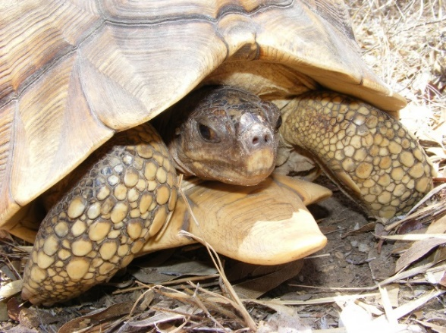
1. Ploughshare tortoise decreased by 50% in Madagascar in 10 years due to poaching for illegal pet trade (Credits: Angelo R. Mandimbihasina and Durrell Wildlife Conservation Trust)
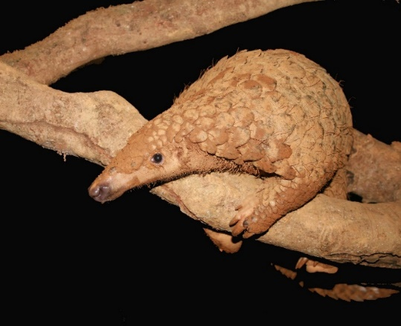
2. Pangolins are one of the most trafficked mammals in the world, yet their plight remains largely unknown to the public (Credits: Dan Challender and Save Vietnam Wildlife)

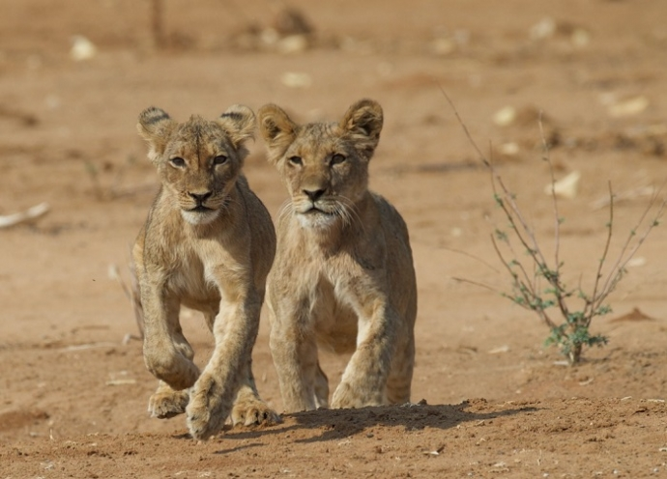
3.Lion bones joined elephant ivory and rhino horn as contentious commodities in the wildlife trade policy arena with a growing export market of bones from deceased South Africa captive-bred lions (Credits: Mike ‘t Sas-Rolfes)
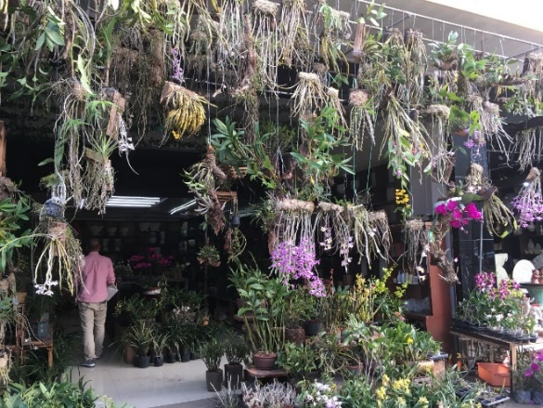
4. Research shows that cacti illegal trade from Latin America is widespread and orchids are wild-collected globally, from Mexico, to Vietnam, to Greece (Credits: Amy Hinsley)
Images available upon request

Organising Committee
E.J. Milner-Gulland, Oxford Martin Programme on the Illegal Wildlife Trade, University of Oxford
Laure Cugnière, Oxford Martin Programme on the Illegal Wildlife Trade, University of Oxford
Paul De Ornellas, Zoological Society of London
Rosaleen Duffy, BIOSEC, University of Sheffield
David Robert, Durrell Institute of Conservation and Ecology, University of Kent
Jacob Phelps, Lancaster Environment Centre, Lancaster University

